Lent Reflections Week 5

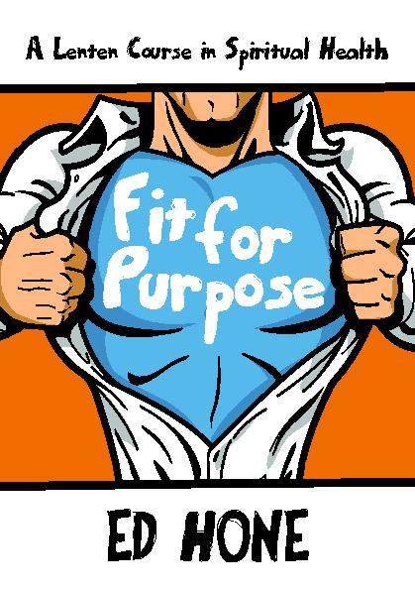
Starbeck Methodist Church, with Park Grove and Scotton, have been following this Lent book.
www.kevinmayhew.com
© Copyright 2012 Ed Hone.
In our previous weeks we have considered (week 1) our ‘spiritual diet,’ how to maintain a ‘balanced diet’; (week 2) what it means to be ‘living in Christ,’ with the love of Christ, and showing Christ to the world; (week 3) letting go of the baggage that weighs us down; and (week 4) living prayerfully.

So now we come to Week 5: “Giving and not counting the cost: the grateful life”
This week’s reflections will be following the structure of the book, but the material has been re-written. We hope you will find it helpful. Ann

1. Preparation
Do you have a small area within your room that you could use as a prayer area? You may find it helpful to have a small table and cover it with a nice cloth (violet for Lent), perhaps light a candle to focus on, and have an item that links with the theme of prayer – such as prayer beads, a praying hands ornament, prayer card, etc.

Sit in a comfortable chair or cushion, tense all your muscles, and one by one let them relax. Focus on the candle or close your eyes and bring yourself into God’s presence. You might find it helpful to repeat some words to yourself… “maranatha, come, Lord Jesus”, or the Jesus Prayer: “Lord Jesus Christ, son of God, have mercy on me..”

2. The previous week
Reflect on all that has happened to you in the previous week. Is there something that has made you smile, or concerned you, that you want to bring before God? Share it with Him.

3. Opening Prayer
Let us pray:
Lord Jesus, as we approach Holy Week,
we recall how you prepared to enter Jerusalem,
knowing what would follow.
We think of all that you suffered for us,
and the love that you showed us upon the cross.
In your resurrection from the dead,
you showed us who you truly are.
Help us to be grateful for all that you gave for us.
Amen.

4. The Grateful Life
There’s a saying that you don’t realise what you have, until it’s gone. We have certainly experienced something of that this week, as we have entered ‘lockdown’ across the country. We have lost our sense of freedom (except for venturing out for the ‘essentials’ such as shopping or work, or daily exercise), especially if you are in isolation or are self-shielding. Some health care needs are being put to one side, so that emergencies can be dealt with. Even shopping for our everyday items, such as bread and milk, can be difficult as items are in short supply or deliveries are running late due to staff working at full capacity and trying to serve the needs of the nation. Even things like toilet rolls(!) have disappeared off the supermarket shelves. As people were being urged not to panic buy, so that shops had a chance to keep up with the supply of stock and so that everyone could benefit, I came across this passage from Proverbs…..

Proverbs 25: 16
¹⁶Have you found honey?
Eat only as much as you need,
Lest you be filled with it and vomit.

I wonder if the panic buyers have been able to use their purchases wisely, or has some of it gone to waste?

The term ‘consumerism’ comes to mind at this time. Do we put more worth on ‘purchasing’ than giving thanks for the items we have received?

Perhaps this week has helped us to be more grateful for the things that we have – for the small items of kindness that have been shown to us; for the food in our cupboards and fridges; for bird-song on the rooftops or in back yards and gardens; for the smile across a garden fence….. I am sure you can think of many others.

We have been finding different ways of coming together in prayer – through telephone calls, emails, the internet, and the post (with thanks to our post men and women); joining in worship and adoration; expressing our thankfulness and sharing our concerns. A healthy spirituality needs to include these things, as they help us to live a grateful life. If this past week has taught us anything, it is that we need to rely on God and not to take anything for granted. Being grateful helps us to appreciate all that God has done for us, for the people he has made us to be and the fellowship we share, and for all that we have received. So, let’s try to be more positive and to live gratefully.

5. Bible Reading
Read Luke 17: 11-19 and let’s join together in praying the Lord’s Prayer.

6. Reflection
I wonder what you noticed about this reading. ‘Social distancing’ perhaps? “keeping their distance they called out…” Even though the lepers couldn’t have close contact with Jesus – note that he didn’t approach them or touch them – it was their faith in him and their reliance on God that healed them as they went to find the priests as they were told. But out of the 10 lepers, only one, a foreigner, turned back to thank Jesus. As he was leaving with the others, he realised that he had been healed. In gratitude, he praised God and thanked Jesus. His life of gratitude, his faith, had made him clean.

7. Prayer of Gratitude
Some things to think about…..

a) Paul said, “give thanks in all circumstances” (1 Thessalonians 5:18) – do you find this difficult?

b) Do you live a life of gratitude?

c) At the end of the day, write down 5 things that today you are grateful to God for.

If you are not feeling positive right now, c) might surprise you.

8. Action
Is there something you would like to do, that would help you with any of the above?

Think of taking small steps…..

9. Worship

Hymn:

Let’s turn to Singing the Faith number 78
A link to the music….
https://www.methodist.org.uk/our-faith/worship/singing-the-faith-plus/hymns/give-thanks-with-a-grateful-heart-stf-78/

Give thanks with a grateful heart,
give thanks to the Holy One;
give thanks because he’s given Jesus Christ, his Son.
Give thanks with a grateful heart,
give thanks to the Holy One;
give thanks because he’s given Jesus Christ, his Son.

And now let the weak say, ‘I am strong,’
let the poor say, ‘I am rich,’
because of what the Lord has done for us;
and now let the weak say, ‘I am strong,’
let the poor say, ‘I am rich,’
because of what the Lord has done for us.

Give thanks.

Henry Smith (b.1952),

Bible verse:
‘And whatever you do, in word or deed, do everything in the name of the Lord Jesus, giving thanks to God the Father through him.’ (Colossians 3: 17).

Prayer:

In your prayer space, focus on your candle or other visual aid.

Bring before God your concerns………….

Bring before God your prayers for others……….

Bring before God your thanks………….

Say again the Lord’s Prayer………..

10. Thought for the Day

To consider throughout this week….

Catechism 23:

“How can we obey God’s rule?
We do everything out of thankfulness for his love for us, shown above all in Jesus Christ. We do God’s will by the power of the Holy Spirit whom he gives us.

See also: John 15:5-7; Colossians 3:17 [see the previous page]; Romans 8:1-11”

(‘What we believe, a Catechism for the use of the people called Methodists,’ TMCP: 2018)

11. Blessing

May the blessing of God,
Father, Son and Holy Spirit,
remain with us, evermore,
Amen.

